Fantaloons Sales managers commented that *%* of males versus females walking in to the store differ based on day of the week. Analyze the data and determine whether there is evidence at *5 %* significance level to support this hypothesis

Sol.

2-Proportion Test

Ho= Proportions of Male and Female are same

Ha= Proportions of Male and Female are not same

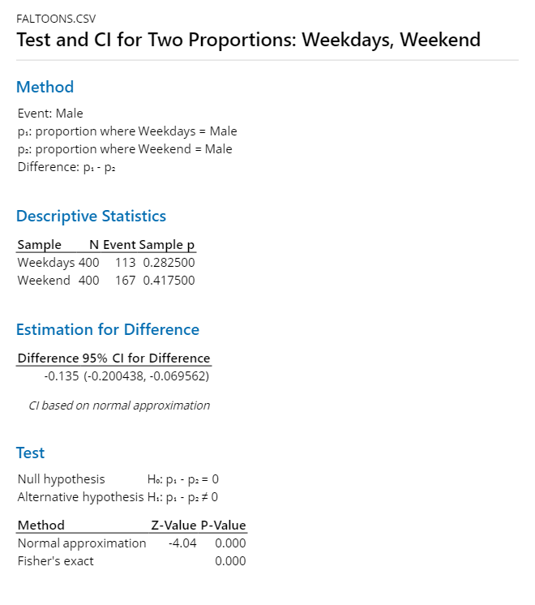

P-value is less than 0.05 and hence we fail to reject Null.Hence proportions of Male and Female are not same